NATIONAL POLICE CHIEFS’ COUNCIL - JOB DESCRIPTION

1. Job Details
Job Title: | Police Science and Technology: Research, Development & Innovation Lead
Reports to: | Professor Paul Taylor (BB2)
Grade | A
Vetting Level | MV/SC - DV to be applied for when in post
Location | Based at 10 Victoria Street, London and/or with flexibility to work remotely. The role may require some travel as necessary.
2. Organisation Chart
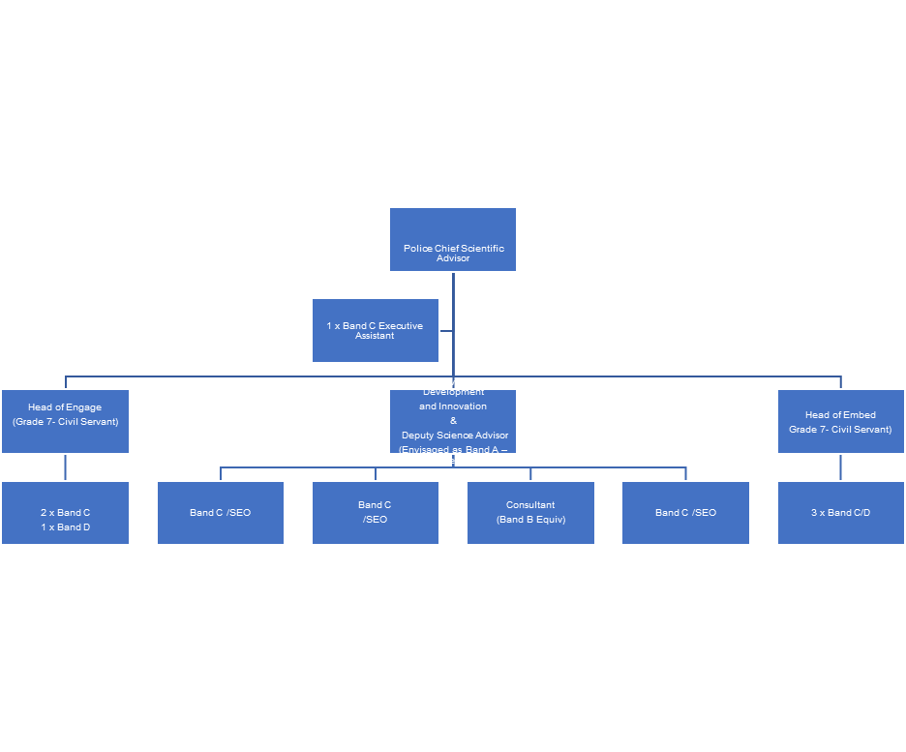

3. Job Purpose
To lead development of research and innovation, including the Office of the Chief Scientific Advisor’s futures programme, across policing, aligning activity to the strategic priorities set out in the Police Science & Technology strategy. They will be expected to provide strategic direction and implementation of the ‘Evolve Pillar’ of the strategy, which has primacy on commissioning and delivering world-class science and technology for NPCC. They will deliver this by, inter alia, proactively identifying key partnerships across the science and technology community and driving collaborations opportunities, including securing co-investment; managing the distribution of the £3.5m STAR funding; helping to build new processes for policing to access and adopt innovative, cutting-edge science and technology capabilities. In addition, the jobholder will Deputise for the Chief Scientific Advisor where required.

4. Knowledge, Skills and Experience
While formal scientific qualifications are not essential, the jobholder requires a detailed knowledge of policing’s science and technology landscape—where and what is going on, and what priorities are driving current efforts. To achieve this requires extensive experience of identifying how S&T can be applied practically within policing and the jobholder should be able to give direction to unfolding work at the Force and national level. They will also be required to work cross-government regularly, representing policing’s interesting in a range of S&T forums and, where possible, leveraging joint effort.
The jobholder will need to demonstrate relevant strategic and operational experience relating to police activities. They must have broad knowledge of the wider policing system and its functions– e.g. APCC, NPCC, HMICFRS, the Home Office, and Dstl, together with a good understanding of the role of key National Law Enforcement and Intelligence Agencies at home and abroad.

The jobholder will need extensive experience of the application and commissioning of science and technology for policing, together with an understanding of the associated legislative requirements.

5. Communications and Working Relationships
The jobholder will need to draw on their extensive communication and interpersonal skills to influence, unite, inform and cohere across a diverse and complex stakeholder landscape, representing the Office of the Chief Scientific Advisor in a range of situations.

They will meet daily with senior leaders in the Police (including Chief Officers) as well as decision-makers, and publicly elected Police and Crime Commissioners. This will be in face-to-face meetings (e.g. where they will Chair various senior Boards) as well as through conference and event attendance. Correspondence via email and phone will be part of their daily routine.

They will engage weekly with wider operational staff and senior leaders across Government, particularly leading close working relationships with the Home Office, GO-Science, and Dstl. They will also engage external partners in academia and industry – particularly to broker productive partnerships, including commissioning of research and technology development for Policing. Again, this will be via face-to-face meetings, events, correspondence and other communications.

They will engage fortnightly with the Private Office for the Minister for Justice and Policing and may occasionally communicate (both f2f and over email) with the Minister.

6. Key Result Areas
Objective 1: Lead on development of a coherent, enterprise-level research, innovation, and futures S&T programme, including undertaking the annual national prioritisation alongside the Home Office Commissioning Hub, and the Police Science Leadership Team.

Objective 2: Ensure central visibility of all S&T activities and, in doing so, promote the ethical and transparency standards defined in the Research Concordat and endorsed by Chief Constables’ Council.

Objective 3: Working closely with Engage and Embed leads (to ensure an end-to-end process), oversee the management of the Police Science, Technology, Analysis and Research (STAR) fund on behalf of the Police Chief Scientific Advisor.

Objective 4: Working with industry partners and government contracting authorities, develop and implement processes to enable commercial exploitation of police led innovation. This includes overseeing and developing the relationship with the Defence Science and Technology Commissioning team and Laboratory, to maximise collaboration and investment opportunities.

Objective 5: Lead the creation and development of a funding strategy for Research and Development of innovative Science and Technology for Policing, including a supporting plan for delivery, a funding map of opportunities (including international) and associated guidance for users.

Objective 6: Deputise for the Police Chief Scientific Advisor at senior level meetings and events as appropriate, including acting with empowered decision making responsibility where delegated.

7. Scope for Impact
The jobholder will have wide-reaching autonomy over their area of responsibility – the Evolve pillar of the science and technology strategy. They will set the strategic vision and assure the operational delivery to meet the overarching objectives of the Pillar.

They will have responsibility for overseeing and reporting on the spend across the NPCC for science and technology research and development and innovation (RD&I) from a national perspective. This responsibility pertains to an initiative requested by Chief Constables’ Council that will see a consolidation of Force RD&I resourcing, likely to be a budget circa. tens of millions. This approach will be new to policing and not simple to implement. The jobholder will face challenges from senior leaders in terms of decision-making around prioritisation, as well as a requirement to ensure value for money and commercial/financial assurance. They will need to be resilient, confident and well-briefed across a broad and varied range of science and technology areas.

They will have strategic and operational delivery responsibility for the STAR Fund Call – this supports innovation projects across policing, following a competitive bidding process (£3.5m in 22/23). They will also be responsible for spend and compliance of a designated budget of around £300k for additional resourcing and non-resourcing within their business area (the Evolve Pillar).
A significant challenge for the jobholder to overcome, will be the capture and prioritisation of policing’s science and technology requirements – to provide a national picture of the gaps, challenges, and areas of focus. This will be new to policing and requires careful handling to ensure an appropriate reflection of focus from local, to regional and national level, and ultimately, consensus from Chiefs as to prioritisation of funding and effort.

The jobholder will be required to build a national network of influencers and champions for science and technology across policing, which will feed requirements as well as help identify opportunities. Establishing this network, and ensuring it remains productive and effective is expected to require significant strategic thought and operational understanding.

8. Dimensions
Budgetary responsibility will be significant:

- They will have responsibility for prioritisation of spend across the Police, for science and technology research and development and innovation from a national, central perspective. This prioritisation will be delivered by a fair competitive process that engages policing, policy makers and academia/industry. The current STAR budget is £5.2m and this is expected to be supplemented by a centralisation of Force RD&I (following an imminent Chief Constables’ Council decision) into what is expected to be in the tens of millions.

- They will be responsible for spend and compliance of a designated budget of around £300k for additional resourcing and non-resourcing within their business area (the Evolve Pillar).

The jobholder is expected to have responsibility for a minimum of 4 staff members:
- 1 x Band C Programmes manager
- 1 x Band C Partnerships Manager
- 1 x Band C Open Science Manager
- 1 x Band B Equivalent Futures Consultant.

